REST API from: catfact.ninja ([Cat Facts API](https://catfact.ninja/#/Facts/getFacts))

To get data from an open server. Firstly, you have to open command prompt (cmd) and then type curl + website (+ specific data location) and press Enter. Then you get what you requested.

Command: curl https://catfact.ninja/fact

This picture show cURL command and what we get from the server. In this case I wan t to know just a random cat fact so I just type end with /fact

If you want to know all fact I can type /facts instead of /fact

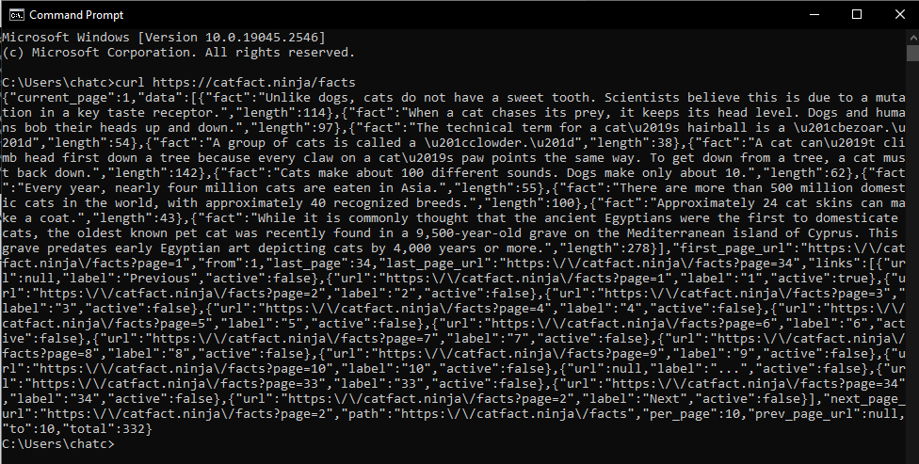

And if you want to read about cat breeds and country you can try typing:

curl <https://catfact.ninja/breeds?page=1> and you will get all the breeds of cat in the page you want to read.

